Centre for Microscopy Characterisation and Analysis

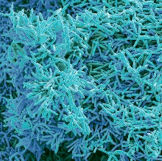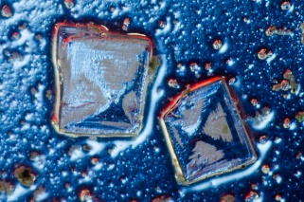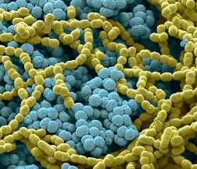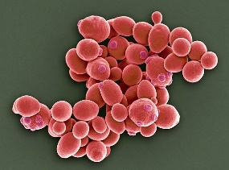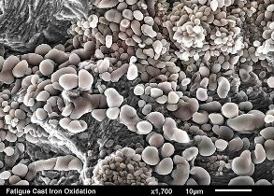

How to access and register for the use of
CMCA
microscopy and imaging capabilities
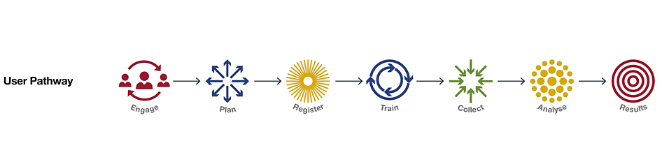

CMCA is accessible to all researchers, including those in universities, medical institutes, government laboratories and industry. This document provides guidance for Microscopy and Analysis, a part of the UWA node of Microscopy Australia and WA node of National Imaging Facility, each with own rates and payment forms.
CMCA also hosts Therapeutics Australia, Bioplatforms Australia’s Metabolomics, Proteomics and Plant Synthetic Biology and the Australian Plant Phenomics Network and these can be contacted directly (please see below).
The CMCA’s expert academic and professional staff are also able to provide analytical services to commercial clients. For Microscopy commercial enquiries, please contact us to discuss your requirements at industry-cmca@uwa.edu.au
Researchers wanting to access CMCA instruments follow a four-step process:
- Engage & plan
CMCA infrastructure is grouped into capabilities comprising one or more related instruments and supporting staff.
Contact staff to discuss your project (see table below).

Not sure what capabilities you need to use to answer your research question?
Please submit an enquiry to one of our discipline-focused enquiry emails (Biosciences, Geosciences, Materials Science) and you will be contacted by staff from relevant Platforms:
https://www.uwa.edu.au/cmca/microscopy-and-analysis

Already know what technique you need?
Please contact the relevant Capability using the links below, providing a brief outline of your project, how you plan to use microscopy in your research, anticipated timelines, and attaching relevant references.

Capability | Email address
Large Geometry Secondary Ion Mass Spectrometry | sims1280-cmca@uwa.edu.au
Nano Scale Secondary Ion Mass Spectrometry | nanosims-cmca@uwa.edu.au
Scanning Electron Microscopy | em-cmca@uwa.edu.au
Flow Cytometry | flow-cmca@uwa.edu.au
Inductively Coupled Plasma Mass Spectrometry | icpms-cmca@uwa.edu.au
Nuclear Magnetic Resonance Spectrometry | nmr-cmca@uwa.edu.au
Optical Microscopy | optical-cmca@uwa.edu.au
Scanning Probe Microscopy | spm-cmca@uwa.edu.au
Transmission Electron Microscopy | em-cmca@uwa.edu.au
X-Ray Microscopy | xct-cmca@uwa.edu.au
WA National Imaging Facility | nif@uwa.edu.au
WA Proteomics Facility | proteomics@uwa.edu.au
Metabolomics Australia (UWA) | metabolomics-cmca@uwa.edu.au
Australian Plant Phenomics Network | appn@uwa.edu.au

- Register
Before your project can commence, you are required to complete the CMCA’s online registration form. This is a one-off process and is only required at the start of each new project or if your circumstances change, such as your status, affiliation, funding, supervisor, or contact details. Health and Safety Induction is part of the registration process, and the relevant staff will provide instructions as required.
To finalise the registration form, you will need to provide contact details for you, your supervisor (if you are a student), and an emergency contact. Based on your discussions with CMCA Team Member, you will select the relevant Platforms/techniques and provide some additional details of your project.
You will also need to provide payment details (Business Unit and Project Grant numbers for UWA researchers or Purchase Order Number for External researchers) for your one-off Membership Fee. See Rates Pages for:
- Microscopy Australia
- WA NIF
The registration form can be found by clicking on the link HERE and then selecting the node Centre for Microscopy, Characterisation and Analysis (CMCA)
- Train
For most CMCA Platforms, training is provided by CMCA staff to enable you to undertake data acquisition and processing independently. It is also possible to pay CMCA staff to provide the analysis work for you.
Upon submission of your registration form, the relevant CMCA staff member will contact you to arrange your training.
- Purchase Instrument Time
To purchase instrument time, please download and complete the appropriate forms:
- Microscopy Australia
- WA NIF

Note: The Microscopy and Analysis Payment form's pre-purchased hours will be credited to you within 72 hours of purchase, so please do not submit the payment form until you have been trained and are ready to commence your work. Pre-purchased hours must be used within 12 months of purchase. Please consider this when deciding how large a block to purchase

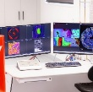
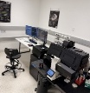
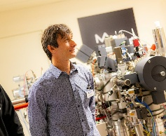
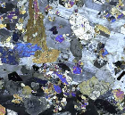
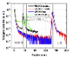
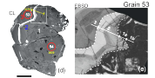
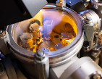
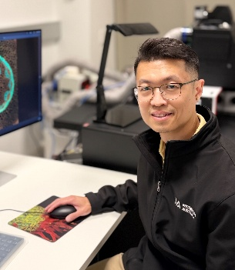
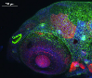
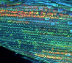
Please remember to mention CMCA
in all publications or outputs!

• EM • OPTICAL • SIMS • SPM • XRM •
We acknowledge the Centre for Microscopy, Characterisation and Analysis at The University of Western Australia, a Microscopy Australia (ROR: 042mm0k03) facility enabled by NCRIS.

• FLOW CYTOMETRY • NMR • ICPMS •
We acknowledge the Centre for Microscopy, Characterisation and Analysis at The University of Western Australia.

• NIF •
We acknowledge the facilities and scientific and technical assistance of the National Imaging Facility, a National Collaborative Research Infrastructure Strategy (NCRIS) capability, at the Centre for Microscopy, Characterisation and Analysis, the University of Western Australia.

